Ethnographic objects and Amerindians Museums:
Notes from a researcher in the field

Renato Athias

Preamble

In 2004, I held a workshop with several kumuá and baiaroá, terms for knowledge-holders or specialists among Amerindians of several linguistic groups in the Upper Rio Negro region, in Iauareté, on the border of Colombia and Brazil. During this workshop, some of the participants were telling a rather intriguing story. I believe it is well known to the people of Iauareté, on the Uaupés River (Athias, 2007). This story sparked my curiosity about the facts and history that Amerindians talk about researchers coming into the field.

After listening to their stories, I became more interested in piecing together the story of how the ethnographic objects outside of this region in various museums and museum institutions were moved. How did these objects leave? Who took them away? Where are they today? All of these questions have motivated a research project in museums in France and around the world, focusing on objects originating from this region (Athias, 2017).

I now have a good knowledge of the national and international institutions where these objects, which used to belong to the Amerindian peoples of the Upper Rio Negro region, in the state of Amazonas in Brazil, are located. Many of the objects collected in this region, especially from 1830 onwards, are currently in the main European museums.

A story was told to me by the kumuá, holders of knowledge and specialists in shamanic healing, in Iauareté: it speaks of a European researcher who hid a trocano in this region, and no one else could find it. The trocano is a kind of large drum made from a hollow tree trunk about 2m long and 1m in diameter, struck with two sticks (one in each hand), and used to emit a particular sound, a signal to warn people. Usually, this object was placed in front of the main door of the Maloca collective houses (Fig.1).

A version of the same story, which circulates among the elders of Iauareté, says that this European took the trocano to Manaus to sell it at a very high price, and that this huge object is now in the collection of the Museum of the Indian in Manaus. Another version says that the European could not take it personally because he could not find a suitable dugout canoe to cross the great waterfall of Ipanoré, since the trocano had to be full of gold and therefore very heavy. The European would then have buried the object somewhere outside Iauareté, in order to recover it later, but would have died before. Therefore, the one who would find it could become very rich! After this story, the Native Americans had a lively debate about how to search for this "gold.

I did a lot of research to locate the year and the name of the European mentioned in this oral account circulating in Iauareté. I was able to determine that it was the Count Ermano de Stradelli who had visited the area at the end of the 19th century and was still part of the oral tradition of the Tariana living in Iauareté. Of course, this anecdote is similar to many stories about non-natives who passed through the area and took artifacts belonging to the Native Americans. Today, these objects no longer belong to that population because they were taken away from their native region. As part of museum collections, they belong to the institutions where the collections are housed. The oldest knowledge holders claim that most of these objects were taken away ... and they often do not know exactly where they are. In fact, at the Museum of the Indian organized by the Salesian Sisters in Manaus, there is a trocano and a significant number of objects taken from these artefacts were stolen from the Amerindian villages of the upper Rio Negro by the missionaries because they were considered part of the "devil cult". Today, these stolen pieces are exhibited in this museum in Manaus (Fig. 5) or elsewhere.

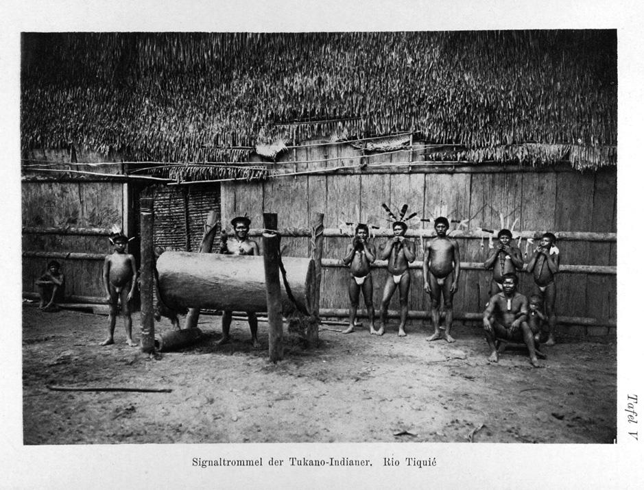
Fig.1 Photo of a trocano by Koch-Grünberg, published in his book: Zwei Jahre bei den Indianern Nordwest-Brasiliens, 1921.

This text seeks to discuss issues related to the objects of the Amerindians, the things of the "enchanted" who are non-human beings with whom the shamans communicate, the artifacts of the ancestors, the objects of the Upper Rio Negro region that have always been a source of interest for researchers in the field of ethnology, but also of museology and for specialists in the material and immaterial cultures of indigenous peoples.

In general, all these objects are to be taken as elements of a much broader understanding of the world linked to the social and political organization as well as to very specific knowledge, common to all the peoples, even to all the clans of this vast region. This is particularly the case for objects of a ritual nature, given that the different dimensions of a shamanic object can only be perceived within the corresponding cosmological model. In the social, regional and political context. These objects are named and associated with a given territory, but also with specific shamanic practices of each group of the Tukano, Arawak and Nadahup language families.

Each of these specific objects has a life of its own and lives forever. This is because they were originally built by founding ancestors of a clan, in a specific place and for the needs of the shamanic practices and rituals of each clan. In these ceremonies, the ancestors are present through these objects which have their own powers, and embody the presence of the ancestors in the present world. Therefore, they are given a specific name. Mythological stories, in particular, are also territorialized, that is, they belong to a place and have been developed to live in that particular place and among the people of a particular clan. Indeed, each clan has a body of knowledge that characterizes it, defines its identity, its relationship to the ancestors, and its interactions with other clans in the same language group. When ceremonies are performed with such objects, whether they are body ornaments or musical instruments belonging to clan members, it is the cultural context of this entire region of the upper Rio Negro that is represented, the world of the ancestors for all the Amerindians of the community. It is revitalized in the present in a ceremony ritualized by a special music known as kahpivaiá.

This specific knowledge resides in the use of a musical tone, a "toante musical. The "toante", as they call it. It is a harmony specific to each clan, which is used in the Miniã-ponã (or Jurupari) ceremonies, with a specific musical repertoire. In the current process of cultural revitalization, the Amerindians of this region are seeking to recover the toantes that make up their Kahpivai, as well as their corporal ornaments, in order to recompose the set of ancestral brothers that are manifested in these celebrations between two linguistic groups of relatives. Some seek not only the original Kahpivaiá music through which their ancestors manifested themselves, but also the set of objects, musical instruments, and body ornaments passed on by their ancestors.

A Kahpivaiá belongs to a particular clan, which is also named and located in a specific geographic space within of this region. It is present in stories and oral histories, and for generations it is also transmitted in the myths that tell the great journey of the Pa'múri Masã of each clan that together form a linguistic group. (Guilherme Maia, Tukano of the Oya-ponã clan, 2009, Iauareté)

Knowledge and ritual objects are closely related, well preserved in carefully crafted basketry, attached to a specific maloca called wi'i, maloca or common house (Fig.2) and only shown to the public during ritualized festivals. The box of basketry ornaments was stored inside each maloca, in an appropriate location representing the outer core of a particular clan's cultural identity. Native Americans tell us that when the box was opened, the baià, or master of the toantes, was to play, with a flute made of deer bone, the Kahpivaiá music that showed the clan's own identity (Athias 2007, 2015). But these basketry boxes, stolen from the malocas before they were burned by missionaries who described them as places of devil worship since the end of the nineteenth century, are therefore now scattered in many museums in Europe.

The elements presented in this text are centered on these shamanic objects used during rituals and widely recognized by the Amerindians who are also currently interested in their symbolic aspects. The question is also centered on some key elements of the processes of "patrimonialization" of Amerindian objects and places, in cultural policy in Brazil as elsewhere. We thus seek to study the circulation of shamanic objects in villages and museums, interfacing with the study of rituals and certain traditional knowledge of these peoples.

The collectors

The circulation of Amerindian objects from the upper Rio Negro (Amazonas, Brazil) outside their specific zone, as far as we know, has been very frequent since the 18th century. In the case of the Rio Negro, I will mention here some names as a reference, since we know that the most famous travelers visited these populations: this is the case, among others, of the Portuguese Alexandre Rodrigues Ferreira (1776), the Austrian Johann Natterer (1835), the British Alfred Wallace (1853), the Italians Illuminato Coppi (1880) and Ermanno de Stradelli (1890) and the German Theodor Koch-Grünberg (1906) as well as Curt Nimuendajú (1927).

They all visited the malocas of this region and described them in their travel accounts, informing us of their uses and how they came to know these objects, which were later brought back to their countries of origin. Alexandre Rodrigues Ferreira, in Philosophical Journey to the Rio Negro, mentions objects of fishing and hunting. Alfred Wallace, in Voyage sur le fleuve Amazone, describes the objects he saw used in the malocas and stated that he was impressed by the architecture of these large communal houses and by the objects that were found there and used for the preparation of food. Johann Natterer sought out all sorts of objects for his collection and realized the very specific interest of the current "collection." In his travel diary, Coppi gives precise information about the ritual objects and tells how he improperly appropriated the mask and committed "sacrilege" by showing it to women. He also records his notes on the Festival of the Masks, which he associates with a demonic ritual calling for "the presence of the devil among the Tariana of Iauareté. But it may still be an important ethnographic account of the Mask Dance, which today no longer takes place as he described it in this region. The mask in question is today an important piece in the Pigorini Museum in Rome (Fig. 3). In several museums in Europe and the United States, some of the ancestors' objects are in permanent exhibitions, but most of them are in technical storerooms and are not on display.

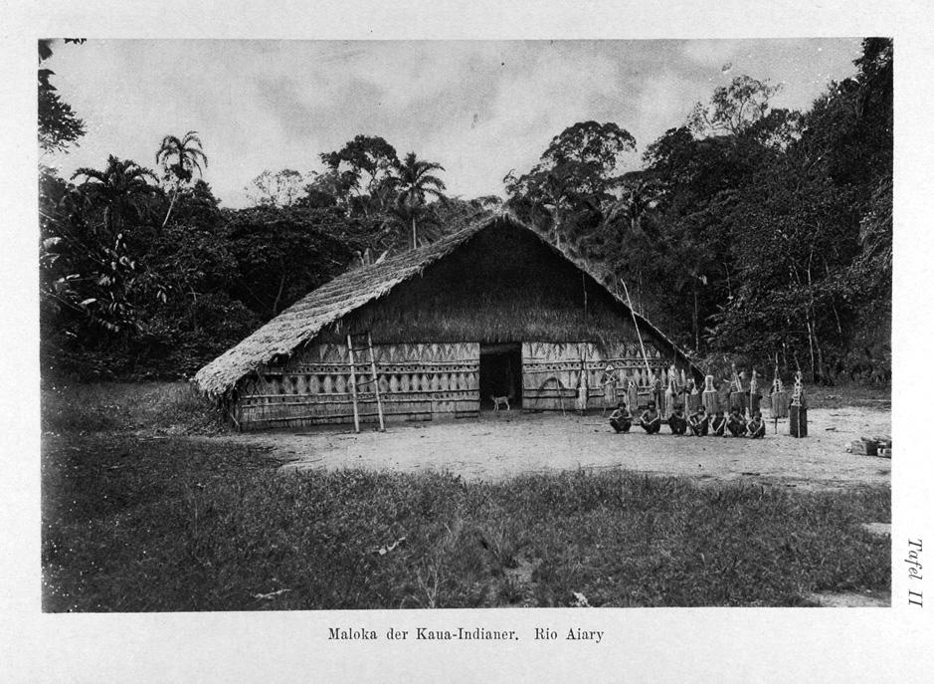
Fig.2 Photo of a Maloca in 1903, community house with dance masks, among the Indians of the Aiary River, by Koch-Grünberg, published in his book: Zwei Jahre bei den Indianern Nordwest-Brasiliens, 1921.

Of course, we do not pretend to speak here of all the objects collected by those missionaries, travellers and naturalists who passed through the region of the upper Rio Negro. We wish to show their existence, and in particular in relation to the practice of a museography that appropriates the objects, but also to make known the accounts of the Amerindians themselves about the objects exhibited. Indeed, the narratives reported in museum exhibits are often biased. Some of the museums I visited during 2016/2017 in Europe, however, are beginning to incorporate Native American narratives into collections and their documentation, while others have yet to evolve their practices. In this article, I base myself mainly on the museum narrative of the Museu do Índio de Manaus, which presents a significant number of objects that are of interest to the debate centred on the notion of museum and addressed in the various meetings of Amerindian museums that have been held recently in Brazil.

In 2011, I began a preliminary investigation in relation to the indigenous peoples of the Uaupés River Basin, on shamanic objects that are found in European museums within specific collections and, especially, in exhibitions. Since then, I have found rare objects that allow us to reflect on the scope of such research. We do not have an exhaustive list of these objects but, being part of the collections of national museums or private museums of Catholic missionaries, they are today already patrimonialized. This implies a profound change in the status of these pieces. In reality, they are no longer Amerindian ritual objects, but art objects owned by a national state. Very often, the documentation accompanying them in the museum does not allow us to really identify their provenance, the ethnic group or the linguistic family of those who made them, and many of the objects are now exhibited with a museum narrative that is primarily of interest only to the museum itself.

What is known today is that these objects, collected by people who were in the region, are now part of important collections belonging to various European countries. They circulate in and between museums, in permanent and temporary exhibitions designed to produce knowledge about the peoples of the Americas. A very significant example of this type of circulation was seen in the organization of the exhibition "Indian Brazil. Les arts des amérindiens du Brésil" at the Grand Palais in Paris, during the year of Brazil in France in 2005. The Tariana mask (Fig.3) from Iauareté was widely publicized as a central object of this exhibition. At no time was it clearly mentioned that this mask was stolen by the Franciscan Illuminato Coppi and brought to Italy in the late nineteenth century. Thus, a stolen object becomes an important symbol of an exhibition, without any mention of its true significance to the Tariana people of the Uaupés River basin (Calávia, 2008).

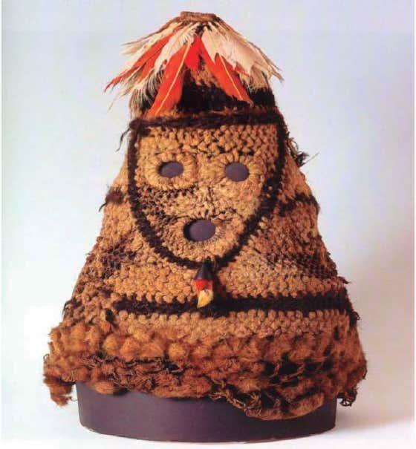

Fig.3 Photo of the Tariana Mask in the Pigorini Museum in Rome
(Source: catalogue of the exhibition "Brazil Indian", Paris, 2005)

However, it is well known that the expropriation of these objects from indigenous areas was very important, the most important of all seems to have been carried out by the Salesians at the beginning of the 20th century. As I mentioned above, with the destruction of the maloca, a community house named wí'i by the Tukano, thousands of ceremonial objects were removed and then transported to Manaus or to other European countries from which these missionaries came. In addition to the national museums, these objects are also found in the private collections of missionary museums in Europe.

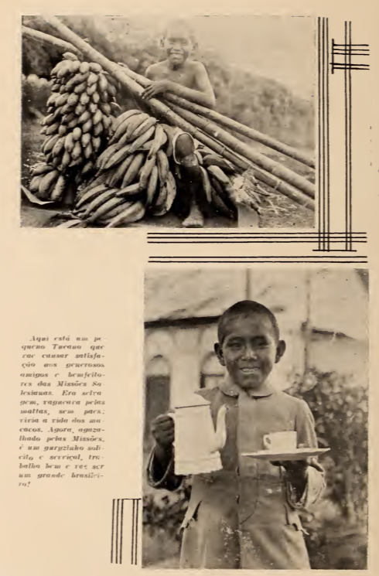
Fig. 4 Photo caption: "Here is a little Tucano who will give satisfaction to the generous friends and benefactors of the Salesian Missions. He was wild, roamed the woods, without parents, living the life of the monkeys. Now maintained by the Missions, he is a caring and helpful boy, he works well, and he will be a great Brazilian!

While conducting my research in the National Museum of Anthropology in Madrid in 2011, I was surprised by the large number of Amerindian objects from the Rio Negro in an ethnographic collection collected and organized by Captain Francisco Iglesias Brage, who in the years 1933 and 1934 mediated a border conflict, between Peru and Colombia. This collection highlights pieces from the Ticuna, Kubeo and Baniwa cultures. There are ornaments, masks, weapons, domestic equipment and musical instruments.

In Madrid, the provincial house of the Salesians also houses a private museum. I was able to make an inventory of these objects related to the traditional practices of the peoples of the Rio Negro. They surely come from these enchanted boxes containing the ornaments and objects of the different Tukano clans, which had the capacity to bring back to life the ancestors represented by the people who knew how to dance with their enchanted ornaments and sing their specific songs.

All of these objects were used in one way or another in ritual celebrations and then collected by Salesian missionaries in exchange for matchboxes and other manufactured goods, but also for the assurance of health services introduced by these same missionaries throughout the region. By burning the malocas and removing ceremonial objects, the Indians renounced the practice of "devil worship" and accepted matchboxes, axes, machetes, knives, aluminium pots, and an entire sanitized lifestyle, from the Salesian perspective. They abandoned their community houses to live in small houses for nuclear families, so as to "avoid orgies", as Giaccone (1949) or Dom Pedro Massa describes. The captions of the photographs in his book “Pelo Rio Mar” show enormous prejudices (Fig.4), also when he describes the strategies developed by the missionaries to try to change the way of life of the Amerindians.

Amerindian Objects and Stories

With the Carlos Estevão de Oliveira Ethnographic Collection (CECEO) of the Pernambuco State Museum in Recife, we carried out a project that allowed for a virtual restitution of objects in several Amerindian villages in the region (Athias, 2008). This began with the creation of a digital platform that was to transport images of the CECEO objects to the villages, and to foster new experiences that included indigenous peoples in this process. The activities carried out on this collection also led to the development of a methodology, a participatory museological diagnosis, implemented in 2012 in the lands of the Pernambuco Amerindians, with the support of the University Extension Services sector (PROEXC), UFPE the Federal University of Pernambuco, and the National Indian Foundation (Funai, Coordination of Maceió).

This diagnosis led us to launch the first Encounters of Indigenous Museums of Pernambuco in 2013, whose description and evaluation of activities can be read in the book organized by Gomes and Athias (2016). For information, we will list below some important actions to document in order to learn from the process of collaboration with Amerindians. In the case of the Upper Rio Negro region, this was mainly to work on Curt Nimuendajú's photographs, belonging to CECEO and taken in 1927 during a trip to this region, and then to publish a book that also includes his ethnographic and linguistic texts (Athias, 2015).

However, this has already been pointed out, the objects of the Amerindian peoples of the upper Rio Negro have been dispersed in different museums around the world. Most of them were removed from the indigenous territories of the region in the nineteenth and early twentieth centuries. Many of them belonged to a particular clan, and to a specific maloca, they are in this way living characters still endowed with names and associated with specific music called toantes.

From 2010, I began to search for these objects in European museums and this search continues today. With each trip to different countries, I set out to list objects, and after contacting the museums, I went on site to their storerooms, to examine and photograph the pieces in the collections in order to build a virtual repatriation project to the Upper Rio Negro region (Athias, 2016). The ultimate goal of this project is also to organize a virtual exhibition of these same found objects in museums located outside the region where the indigenous peoples who produced them live.

It is worth noting, for information purposes, the experiences with exhibitions organized in collaboration and with the involvement of Native Americans, either in the form of shared curatorship or in the documentation process, as they are rich and unique experiences. To work with Native American peoples in museums, one must have a strong interest in the museum, but also have the resources to carry out this type of collaborative project. In this case, it was not possible to carry out these activities because the CECEO, whose project had been approved by the Pernambuco State Support Foundation (FACEPE), did not have sufficient resources to finance the participation of indigenous representatives.

Objects and Museographic Narratives

Following on from an earlier text addressing this issue (Athias, 2017), I will now focus more specifically on the museographic aspects of the exhibition/installation we organized at the Pernambuco State Museum in Recife, entitled "Myths, Dances and Rituals of the Amerindian Peoples". These give elements to problematize ethnological research, documentation, patrimonialization of shamanic objects, but also to promote the process of collaboration with indigenous representatives in the ethnographic collections of museum institutions, incorporating their stories in the exhibitions.

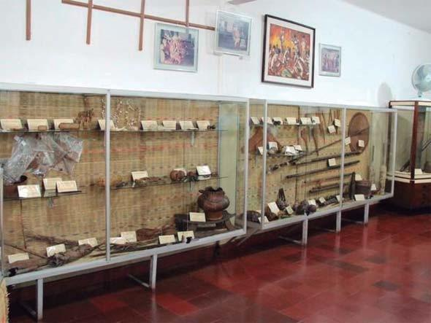
Fig.5. Photograph of one of the rooms of the "Museu do Índio" in Manaus, with an exhibition set up in the 1970s by the Salesian Sisters.

In the realization of the exhibition/installation mentioned above, we sought to focus on a museographic project that combines music, dance, shamanic objects and photographs from the collection. They interact with each other, as in a dialogue, and thus bring the ethnographic objects to life, showing the relationship of indigenous peoples with their shamanic practices in the Amerindian communities from which the objects were taken to the museums. To realize this exhibition/installation, and to give a certain scope to this dialogue with the public, we selected, from the ethnographic collection of the museum, a set of objects used in the rituals linking humans to the "enchanted" who are those invisible entities of the cosmology, involving traditional shamans and therapists, capable of interacting with the music, essentially constituted of "torés" specific to the rites, and choosing photographs that represent the different peoples.

In this context, we used the photographs taken by Curt Nimuendajú, as well as those of Carlos Estevão de Oliveira, on ritual dances, such as the toré, and shots showing the ceremonial use of the drink prepared with jurema, also called ajucá wine. The collection of all these objects was only possible because anthropological research was carried out with indigenous representatives, who came to the museum to present their stories and complete the documentation made on these objects belonging to the Ethnographic Collection.

To carry out the exhibition in the State Museum of Pernambuco with these ethnographic objects still related to current shamanic practices, was an attempt to increase the visibility and representation of the indigenous peoples of today. Indeed, these objects, collected for the museum decades ago, are still present in the territories where the Amerindians live and maintain their traditional medicinal and shamanic healing practices. The result of the participatory work with those who attended the exhibition/installation preparation sessions to organize the narrative through this lens was striking. Our Native American collaborators revealed a strong connection to many of the objects in the collection. During this co-curatorial process, we found that the búzios (a type of hollow wooden ritual ﬂute) belonging to the Fulni-ô, incorporated into the collection, were completely deteriorated, and could not reproduce the sound of the actual Fulni-ô búzio. They could no longer produce the typical sound of the búzio. We therefore suggested to the Fulni-ôs that they prepare a new pair of búzios, to be incorporated into the Museum's collection to replace those that had deteriorated over time. The project, led by Fulni-ô colleague Wilke Melo himself, provoked much discussion because the original pair of búzios had never left their village, so the new búzios made under these circumstances necessarily had to be recognized as an authorized and authenticated copy (Fig.6).

On the opening day of the exhibition, a Fulni-ô dance group presented the appropriate songs used in their parties. On this occasion, the damaged búzios were replaced with copies certified by Fulni-ô experts. By introducing these new búzios into the exhibition, an objective of the project was achieved, as the exhibition once again made contemporary the Amerindian participation both in the museographic project, the making, documentation and mounting of the objects to be exhibited, but also in the presentation of their current medicinal and shamanic practices.

Thus, during the realization of this exhibition / installation composed of objects collected by Carlos Estevão at the beginning of the last century, the suggestions of the Amerindians, aroused by very specific aspects of the objects of shamanic use, allowed to show that the use of these objects keeps an important role today. The exhibition and the entire process of creating the exhibition spaces reaffirm the importance of a methodological debate similar to that initiated by Franz Boas (Stocking, 1982) on ethnological issues and the importance of such studies for a better understanding of the pieces in ethnographic collections.

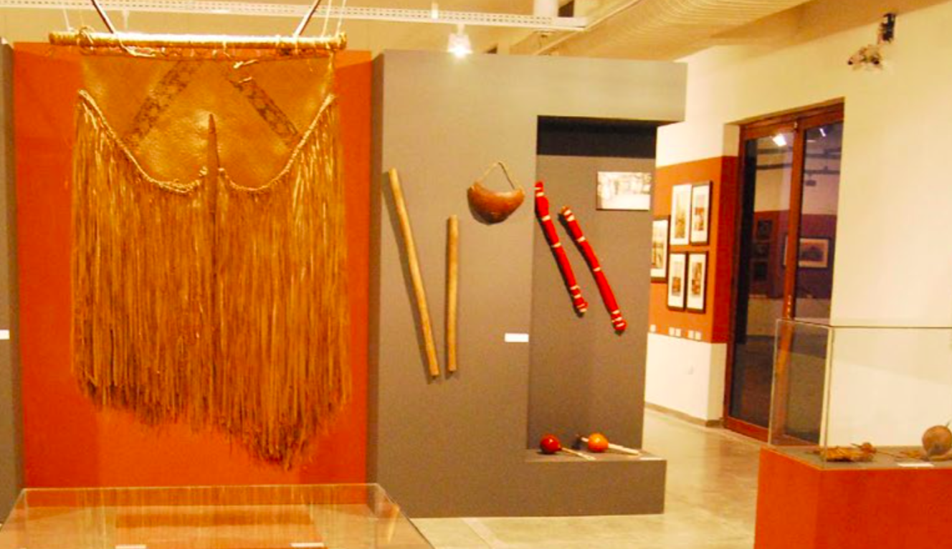
Fig. 6. In the foreground, we can see the Kokrit ritual mask and in the background, the two authenticated copies of the Fulni-ô buzios placed alongside the elders in the exhibition/installation at the Pernambuco State Museum, Recife, 2010. (Photo: R. Athias)

Certainly, when Carlos Estevão began his personal collecting, he did not have this same conception of collecting in mind, nor perhaps even a specific interest in the ethnographic aspects of an object related to shamanic practices, even though he outlines knowledge about the "enchanted" (Encantados) briefly in his 1938 article. However, an anthropological research starting from the theoretical and methodological issues already widely discussed by José Reginaldo Gonçalves (1990), Arjun Appadurai (1986), and James Clifford (1988: 215-25) allows us to address different interfaces of the questions posed by the objects in the ethnographic collections, and to conduct research with Native American representatives in a posture of intercultural collaboration.

The objects and photographic images in this exhibition/installation, referred to here, were selected with the aim of relating ethnographic sound objects from five indigenous peoples who inhabit the states of the Northeast region of Brazil. In this set of photographs taken by Curt Nimuendajú and Carlos Estevão de Oliveira, the pictures and music presented show the relationship of these peoples with nature, with the "Encantados" and with spirituality. Different peoples are represented here. The Rankokamekrá from Maranhão participated in the presentation of the Kokrit ritual, especially through the fabrication of masks specially created for this event. The Tremembé from Almofala, from Ceará, showed the Tore dance and the use of "Mocororó", a cashew-based drink important for their ceremonies. The Tuxá, from Rodelas, presented the dances and the ritual accompanied by the drink prepared with the jurema plant. The Fulni-ô, from Águas Belas, danced the Toré with the búzios, wind instruments that produce the appropriate music for this ritual in the village. Finally, the Pankararu, from Brejo dos Padres in Pernambuco, gave their presentation of the Toré dance with the consumption of ajucá wine, also made from jurema and consumed throughout the ritual. The photographs exhibited were taken between 1935 and 1942 and are part of a collection of images that is being studied in the project "Memory, Research and Documentation of the Carlos Estevão de Oliveira Collection".

Amerindians Museums

The growing debate among indigenous peoples about the presence of their objects in ethnographic museum collections and the creation of Amerindian museums, or cultural centers that stem from indigenous processes, is currently visible on the national and international scenes in Brazil, Canada, Australia, Mexico, Peru, Colombia, the United States and other countries. By building collections and giving them meaning, indigenous peoples are putting an end to the endless colonial discourse of the official national museums and are demanding that the exhibitions held there be representative of their true traditions. Thus, a first-person narrative construction is established. This fits in with the examination of the role or importance of so-called ethnographic collections (Athias, 2010) while reinforcing the organization of indigenous peoples' museums, each inserted in a specific context.

In addition to telling alternative versions of history, Amerindians museums become an instrument of the "Native American cause" (Chagas 2007, 181). They assume a certain social role through the construction of narratives now orchestrated according to the indigenous managers' own projects. A collective process is then formed within the village. These institutions, which were not created "for" the community, constitute the museum "of" the community (Lersch and Ocampo, 2004:4).

American Indian museums show great diversity in that the notion of "museum" as an institution or process is reappropriated and reinvented according to each reality. Ethnic identification can be affirmed through objects that are embedded in museological processes, linked to intercultural education, political mobilization and social organization. They do not constitute themselves as "a museum about Indians, but by Indians" (Vidal, 2008:3) presenting "their own views on their culture" (Chagas, 2007:176). "These collections do not come from a booty but from an act of will", from "the initiative of a collective not to show the reality of the other, but to defend themselves" (Lersch and Ocampo, 2004:3).

Through these processes, the safeguarding of a common heritage is done through the appropriation of technical and conceptual tools for the management of representation processes, which have multiple meanings. Indigenous museums are deeply linked to the forms of social organization and political mobilization of their populations.

The practices of collecting for preservation, classification and exhibition that are present in anthropologists' research are carried out in a different way within the framework of Amerindian museological action. The implementation of collecting practices aimed at museological preservation and communication is oriented towards the construction of representations about themselves.

Amerindian museological action is linked to the reality of distinct peoples and to the translation of procedures that allow them to construct self-representations based on heritage, culture and memory. The diversity of translation modes represents the multiplicity of possibilities for museumization, as first-person representation, performed by indigenous peoples themselves (Gomes, 2012). This "discovery" of museums by Native Americans (Freire, 1998 p. 5-29) occurs in a fundamental context of contemporary political mobilization and struggle. Once classically "represented" in national museums through their ethnographic objects, current processes of indigenous musealization can culminate in the repatriation of collections formed in colonial or imperialist contexts, as in Canada and Australia (Clifford, 1988).

This political and conceptual rupture has opened up a space for revision of the anthropological view of the "other", constructed by the said material culture. The indigenous peoples of Pernambuco and other Brazilian states have appropriated different tools of representation expressed in various languages, including the construction of museums and other spaces associated with the administration and management of memory and cultural heritage. The training actions derived from the experiences of museum processes in Amerindian territories respond to the growing demand of indigenous peoples. They are seeking to qualify themselves to effectively manage museological processes by adapting technical and conceptual tools to the realities of their own experiences.

We apply a methodological strategy by analyzing museological processes and their social relations in terms of the interactions between society, culture and nature within the framework of different systems of thought. Located in the field of humanities, it is permanently linked to other social sciences such as philosophy, art history, archaeology. The studies of museology refer to the concept of cultural heritage, that is to say the whole of the material and immaterial references which define the identification of human groups in time and space. From the recognition of the heritage that identifies them, the different societies create, develop and maintain museums. As societies articulate themselves in different ways, they create and develop different forms of museums. The museum thus appears as one of the most fascinating representations of human society. To study knowledge, its history, its development, its importance in different societies is one of the tasks of museology.

The study of museums, objects, and collections, developed by Gomes and Athias (2016), engages in a fruitful dialogue on issues related to heritage and the management of ethnographic collections. These issues are becoming central to research with indigenous peoples. Added to this are the cultural issues that now play a central role in the development, growth, and improvement of individuals in society and, most importantly, in the understanding and capitalization of the plurality of cultural expressions that characterize the country. Therefore, studies on collections and processes of museum creation within indigenous development highlight the issues of the debate of collaborative activities with American Indians. They need to be clearly articulated so as not to steer this process toward Native American cultural folklore.

This research also raises questions about the accurate understanding of the political and technical dimensions in contemporary museology. Further training and qualification of those involved in these processes is needed. This has been important in the development of "houses of memory," "cultural centers," and "Native American museum" projects. If, on the one hand, there is an urgent demand for specializations, on the other hand, we observe a better understanding, especially technical, of the processes of musealization within Amerindian territories. In this sense, the experiences presented in this dossier are sufficiently convincing to identify these demands, to provide significant responses and, above all, to give adequate direction to such processes.

There is also a strong demand for local and regional museums that seek to promote the historical memory of ethnic minorities, social movements, identity movements, gender markers, contingents of immigrants who have contributed to the recent history of the state (e.g., Japanese, Marranos, etc.). Pernambuco is ahead in the cultural field and acts as a vanguard and reference, which should be valued at a time when museums are developing, and which fully justifies research initiatives in ethnographic collections and for indigenous museums.

Our heuristic base understands the museum as a socially and culturally constructed place of communication. It is composed of expressive collections that reflect ways of life socially captured by certain human groups, embracing their values, motivations, thoughts and behaviors. We believe that the concept of cultural heritage has been systematically expanded in its semantic dimension, to include principles of selection of objects that can be "patrimonialized" and "musealized".

Thus, we seek to grasp and appreciate the different types of assets? agents? by understanding the concepts and meanings that certain groups attribute to their tangible and intangible achievements which, in turn, give rise to various forms of museums, classifications or collections. Although anthropology has a core focus, the theoretical guidelines that guide us are based on a reciprocal dialogue with different fields of knowledge. The current perspective of museology studies requires an interdisciplinary dialogue applied to a wide range of practical activities, including those related to the chain of safeguarding (conservation-restoration and documentation), museological communication (expography and educational action), cultural heritage management and memory management tools.

Supporting the processes of Native American creation of these museum spaces reflects, in combination, the challenges of theoretical training allied with applied training at the interface between anthropology and museology. The study of ethnographic objects and collections (Athias, 2010), as well as that of Native American museums (Gomes, 2012) increasingly requires an interdisciplinary dialogue. Culture takes on a central dimension in understanding the different languages developed by individuals and social groups. In particular, it requires a deeper understanding of the ethnographic materials displayed in museum collections and the new forms of collecting developed with indigenous peoples.

Bibliographical References

ANDRELLO, G. Fala, objetos e corpos. Autores indígenas no alto rio Negro. Revista Brasileira de Ciências Sociais. vol. 25, n. 73, p. 5-23, 2010.

APPADURAI, A. The Social Life of Things: Commodities in Cultural Perspective. Cambridge : Cambridge University Press, 1981.

ARANTES, A. A. A salvaguarda do patrimônio cultural imaterial no Brasil.
Kopytoff Igor, 1986.

ATHIAS, R. M. Kumuá, Baiároá e Yaís. Os especialistas da cura entre os índios do rio Uaupés-AM. Somanlu (UFAM), v. 7(1), p. 87 - 105, 2007.

ATHIAS, R. M. Os Objetos, as Coleções Etnográficas e os Museus. In: Angel Espina Barrio, Antonio Motta, Mário Hélio Gomes. (Org.). Inovação Cultural, Patrimônio e Educação. 1ed. Recife : Massagana, 2010, p. 303-312.

ATHIAS, R. Reconhecimento dos Rios Içana, Ayari, Uaupés, Apontamentos linguísticos e fotografias de Curt Nimuendajú. Rio de Janeiro : Museu do Índio, 2015.

ATHIAS, R. & GOMES, A. Coleções Etnográficas, Museus Indígenas e Processos de Musealização, Recife : Editora da UFPE, 2016.

ATHIAS, R. Objetos Xamânicos em Museus na Europa e EUA, Projeto de Pesquisa, mimeo, 2017.

BENNETT, Tony. Pasts Beyond Memory. Evolution, Museums, Colonialism. London and New York : Routledge, 2004.

CALÁVIA, O. Os índios no Grand Palais. Revista Ilha, Florianópolis, 2008.

CARDINI, Laura. Las « puestas en valor” de las artesanías en Rosario : pistas sobre su « aparición” patrimonial. Cuadernos de Antropología Social, n. 21, p. 91-109, jan./ jul. 2005.

CHAGAS, Mário. Museu do índio. Uma instituição singular e um problema universal. In: BELTRÃO, Jane Felipe; ECKERT, Cornélia; LIMA FILHO, Manuel Ferreira (Orgs.). Antropologia e Patrimônio Cultural. Diálogos e desafios contemporâneos. Blumenau : Nova Letra, 2007, p.175-198.

CHOAY, Françoise. A alegoria do patrimônio. 3 ed. São Paulo : Unesp, 2006.

CLIFFORD, James « On Collecting Art And Culture”, in The Predicament of Culture : Twentieth- Century Ethnography, Literature, and Art, Cambrigde, Massachusetts : Harvard University Press, 1988, pp. 215-251.

CRANE, Susan (Org). Museums and Memory. Stanford : Stanford University Press, 2000.

DIAS, Nélia. Le Musée d’Ethnographie du Trocadéro 1878-1908. In : Anthropologie et Muséologie en France. Paris : Editions du CNRS, 1991.

DIAS, Nélia. « The Visibility of Difference: nineteenth-century French anthropological collections”. In : The Politics of Display. Museums, Science, Culture, edited by S. Macdonald. London and New York : Routledge, 1998.

FREIRE, José Ribamar Bessa. A descoberta dos museus pelos índios. In: Cadernos de etnomuseologia. Nº 01. Rio de Janeiro : Programa de Estudos dos Povos Indígenas, Departamento de Extensão; UERJ - Universidade do Estado do Rio de Janeiro, 1998.

GIACCONE, A. Os Tukanos. Salvador : Gráﬁca Salesiana, 1949.

GOMES, Alexandre Oliveira. Aquilo é uma coisa de índio : objetos, memória e etnicidade entre os Kanindé do Ceará. Dissertação (Mestrado em Antropologia) : Recife, Universidade Federal de Pernambuco, 2012.

GONÇALVES, J. R. dos Santos. « Monumentalidade e cotidiano : os patrimónios culturais como género discursivo”. In : Antropologia dos Objetos : coleções, museus e patrimónios. IPHAN, p. 141-157, 2007.

GRUPIONI, Luís Donisete Benzi. 1998. Coleções e Expedições Vigiadas : Os Etnólogos no Conselho de Fiscalização das Expedições Artísticas e Cientíﬁcas no Brasil. São Paulo : Hucitec/Anpocs. 341 pp. ?

HANDLER, Richard. « On Having a Culture”, in George W.Stocking, jr. (ed.), Objects and Others. Essays on Museums and Material Culture, Madison, The University of Wisconsin Press, 1985, pp. 192-217.

KIRSHEMBLATT-GIMBLETT, B. 2006. « World Heritage and Cultural Economics”, in I. Karp e all., eds., Museum Frictions, Durham, Duke University Press, pp. 161-202.

MENESES, Ulpiano T B. « Problemática da identidade cultural nos museus : de objetivo (de ação) a objeto (de conhecimento)”. Anais do Museu Paulista : História e Cultura Material, São Paulo, n.1, p.207-22, São Paulo, 1993.

LERSCH, Teresa Morales; OCAMPO, Cuauhtémoc Camarena. O conceito de museu comunitário. História vivida ou memória para transformar a história? In : Conferencia
Nacional de la Asociación Nacional de Artes y Cultura Latinas, 2004, Kansas City. Disponível em : http://www.abremc.com.br/artigos1.asp?id=5. Acesso em : 20 jul. 2010.

POULOT, Dominique, 1997. « Une nouvelle histoire de la culture matérielle”. In : Revue d’histoire moderne et contemporaine, 44, 2, pp. 344-357.

ROTMAN, M. González de Castells, A. N. Patrimônio e Cultura : Processos de politização, mercantilização e construção de identidades. In: LIMAFILHO, M. F.; BELTRÃO, J. F.; ECKERT, C. (Org.). Antropologia e Patrimônio Cultural. Blumenau : Nova Letra, 2007.

STOCKING, Jr. A Franz Boas Reader : The Shaping of American Anthropology, 1883-1911. Chicago : University of Chicago Press, 1982.

STRADELLI, Ermanno, Lendas e notas de viagem. A Amazônia de Ermanno Stradelli, São Paulo : Martins Editora, 2009.

WAGNER, R. A invenção da Cultura. São Paulo : Cosac Naify, 2010.

VIDAL, Lux Boelitz. O museu dos povos indígenas do Kuahí. Gestão do patrimônio cultural pelos povos indígenas do Oiapoque, Amapá. In : BRUNO, Maria Cristina Oliveira; NEVES, Kátia Regina Felipini (Orgs.). Museus como agentes de mudança social e desenvolvimento. Propostas e reflexões museológicas. São Cristóvão : Museu de Arqueologia do Xingó, 2008, p. 173-182.

With the support of the Associação Saúde Sem Limites (SSL). The results of these workshops were published in a book entitled: Pa'muri Masa, A Origem dos Nosso Mundo, Revitalizando as Culturas dos Povos Indígenas do rio Papuri e Uaupés (Athias et al., 2006).
Tukano, Tariana, Uanano, Waikhan, Tuyuka, Desana and Arapaso.
The Museu do Índio in Manaus is an institution maintained by the Salesian Sisters (Fig.5). The collections of this museum come from the malocas whose destruction was promoted by the missionaries of the upper Rio Negro until 1933.

